WIRELESS SENSOR NETWORKS AND MOBILE COMMUNICATION

PRACTICAL-2

NAME: Neeraj Appari T073

AIM: Exploring and understanding TinyOS computational concepts: - Events, Commands and Task.

- nesC model

- nesC Components

TinyOS

TinyOS is an embedded, component-based operating system and platform for low-power wireless devices, such as those used in wireless sensor networks (WSNs), smartdust, ubiquitous computing, personal area networks, building automation, and smart meters.

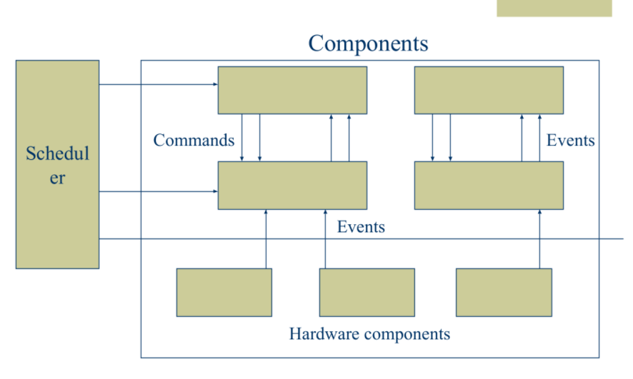

Tasks

1. Perform the primary computation work
2. Atomic with respect to other tasks, and run to completion, but can be pre-empted by events
3. Allow the OS to allocate a single stack assigned to the currently executing task
4. Call lower-level commands
5. Signal higher level events

Commands

1. Non-blocking requests to lower-level components
2. Deposit request parameters into a component’s
3. frame, and post a task for later execution
4. Can also invoke lower-level commands, but cannot block
5. To avoid cycles, commands cannot signal events
6. Return status to the caller

Events

1. Event handlers deal with hardware events (interrupts) directly or indirectly
2. Deposit information into a frame
3. Post tasks
4. Signal higher level events
5. Call lower-level commands

NesC

NesC Programming Model

1. Programs are built out of components
2. Two types of components: Modules: Implement program logic Configurations: Wire components together
3. Components use and provide interfaces
4. Components are wired together by connecting interface users with interface providers
5. Interfaces contain definitions of 1) Commands 2) Events
6. Components implement the event handlers they use and the commands they provide.

NesC Components :

Anecdotally, nesC’s component model has been invaluable for event-driven sensor applications. The success of the component model is shown by the way in which components are used in the TinyOS code; applications are small, and make use of a large number of reusable components. Moreover, nesC’s component model makes it possible to pick and choose which parts of the OS are included with each application